Module 2 Assignment

Title: Unsplash Image Agent (n8n)
Assignment Question
Create a simple automation workflow using n8n that works as an Image Agent. The workflow should take a keyword as input and return 3 image URLs from Unsplash.

Requirements
1. Webhook Setup (Input)
Create a Webhook node.
Set the method to GET.
The workflow should accept a query parameter like:
?q=coffee
2. Unsplash API Integration
Add an HTTP Request node.
Method: GET
URL:
https://api.unsplash.com/search/photos
Add the following query parameters:
query → {{$json.query.q}}
per_page → 3
Add the following header:
Authorization → Client ID YOUR_UNSPLASH_ACCESS_KEY
3. Process Image Data
Add a Set node.
Keep only one field:
images = {{$json.results.map(r => r.urls.full)}}
4. Return Response
Add a Respond to Webhook node.
Return the images field as JSON output.
Expected Output Format
{
"images": [
"url1",
"url2",
"url3"
]
}

Submission Requirements
●Screenshot of the complete workflow
●One test URL (Webhook URL with query)
●Output JSON response
● Execution Video

N8N WORKFLOW -SCREEN SHOT
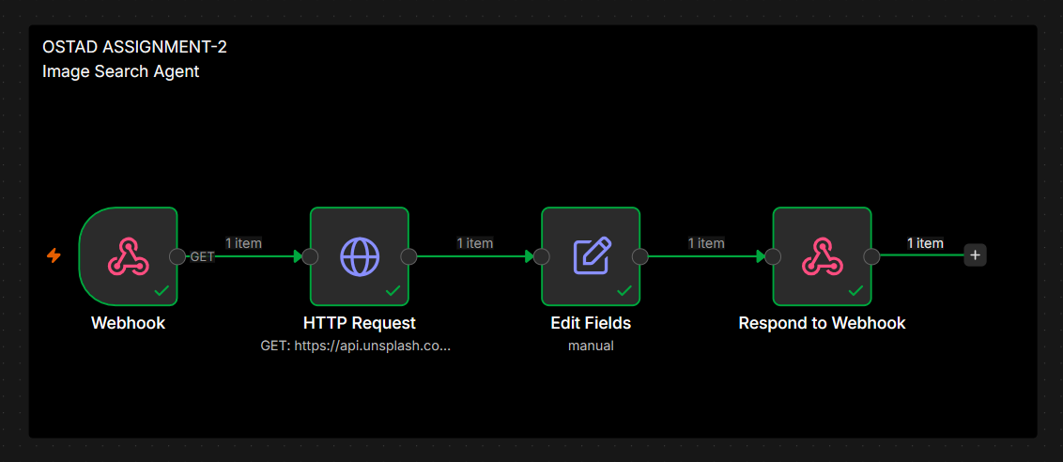

N8n workflow (Backend)

Lovable site
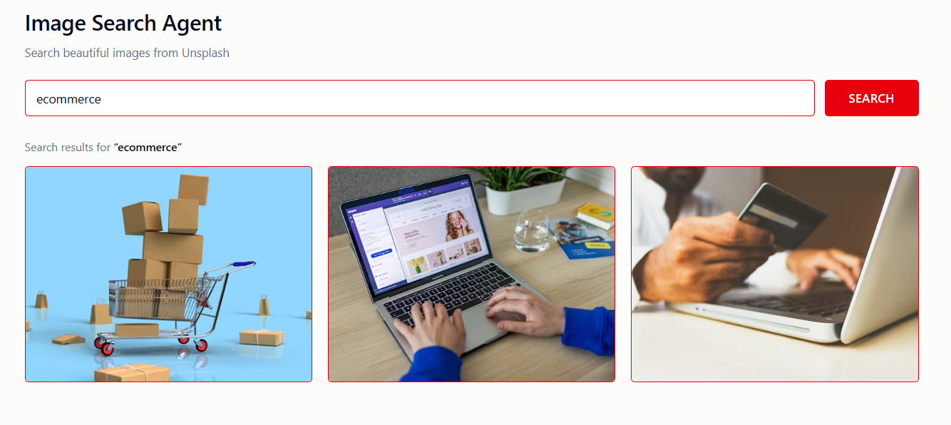
Lovable site (Frontend): https://imagesearchagent.lovable.app/

N8n json file (image search agent):
{
"nodes": [
{
"parameters": {
"path": "imgagent",
"responseMode": "responseNode",
"options": {}
},
"type": "n8n-nodes-base.webhook",
"typeVersion": 2.1,
"position": [
0,
0
],
"id": "43002bce-ac53-4bb1-9234-4a9d2f3419ec",
"name": "Webhook",
"webhookId": "ddb16e9e-8675-4f01-891e-d1cdae7f3df9"
},
{
"parameters": {
"url": "https://api.unsplash.com/search/photos",
"sendQuery": true,
"queryParameters": {
"parameters": [
{
"name": "query",
"value": "={{ $json.query.q }}"
},
{
"name": "per_page",
"value": "3"
},
{
"name": "client_id",
"value": "sV7w7nbeSfj9QXEkfvnlM94_tYIh82EiV2372oHIn-Q"
}
]
},
"options": {}
},
"type": "n8n-nodes-base.httpRequest",
"typeVersion": 4.5,
"position": [
224,
0
],
"id": "31285293-9f02-4049-9da8-2b5d2da3bfb4",
"name": "HTTP Request"
},
{
"parameters": {
"assignments": {
"assignments": [
{
"id": "050650a8-98ec-422b-99ce-84bbd2d47bae",
"name": "imglist",
"value": "={{$json.results.map(r => r.urls.full)}}",
"type": "string"
}
]
},
"options": {}
},
"type": "n8n-nodes-base.set",
"typeVersion": 3.5,
"position": [
448,
0
],
"id": "b2e38da5-d73e-450c-8b8b-67b6e13ca1e4",
"name": "Edit Fields"
},
{
"parameters": {
"options": {}
},
"type": "n8n-nodes-base.respondToWebhook",
"typeVersion": 1.5,
"position": [
672,
0
],
"id": "d0c58f69-73d3-4664-ad0c-a368cef7e192",
"name": "Respond to Webhook"
},
{
"parameters": {
"content": "OSTAD ASSIGNMENT-2\nImage Search Agent",
"height": 400,
"width": 976,
"color": "#000000"
},
"type": "n8n-nodes-base.stickyNote",
"position": [
-48,
-176
],
"typeVersion": 1,
"id": "21eea74c-1234-4933-a182-2e9278f868c0",
"name": "Sticky Note"
}
],
"connections": {
"Webhook": {
"main": [
[
{
"node": "HTTP Request",
"type": "main",
"index": 0
}
]
]
},
"HTTP Request": {
"main": [
[
{
"node": "Edit Fields",
"type": "main",
"index": 0
}
]
]
},
"Edit Fields": {
"main": [
[
{
"node": "Respond to Webhook",
"type": "main",
"index": 0
}
]
]
}
},
"pinData": {},
"meta": {
"instanceId": "3f51955c1e7252d848aff60eda76e567459d62c941f2d071a207c1cc004cf1d2"
}
}

Webhook url: ostadn8n.app.n8n.cloud/webhook/imgagent?q=ecommerce

Response in browser: {
"imglist": "[
\"https://images.unsplash.com/photo-1664455340023-214c33a9d0bd?crop=entropy&cs=srgb&fm=jpg&ixid=M3wxMDM1NTU0fDB8MXxzZWFyY2h8MXx8ZWNvbW1lcmNlfGVufDB8fHx8MTc4NzE2NDI5NXww&ixlib=rb-4.1.0&q=85\",
\"https://images.unsplash.com/photo-1688561808434-886a6dd97b8c?crop=entropy&cs=srgb&fm=jpg&ixid=M3wxMDM1NTU0fDB8MXxzZWFyY2h8Mnx8ZWNvbW1lcmNlfGVufDB8fHx8MTc4NzE2NDI5NXww&ixlib=rb-4.1.0&q=85\",
\"https://images.unsplash.com/photo-1563013544-824ae1b704d3?crop=entropy&cs=srgb&fm=jpg&ixid=M3wxMDM1NTU0fDB8MXxzZWFyY2h8M3x8ZWNvbW1lcmNlfGVufDB8fHx8MTc4NzE2NDI5NXww&ixlib=rb-4.1.0&q=85\"
]"
}

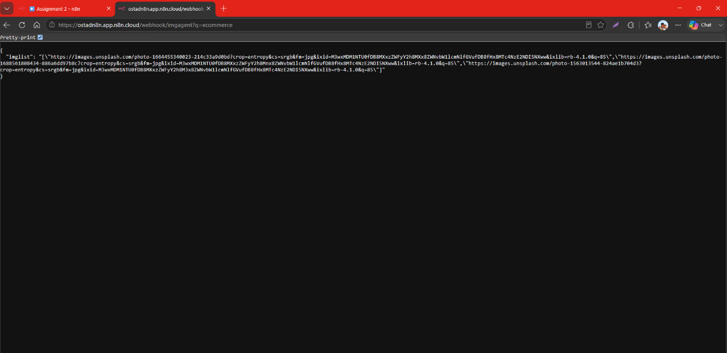

Response in website

Lovable url: https://imagesearchagent.lovable.app/

